Travel Cost Efficiency of Lane-based Charging System

In the simulation, uniform, random and normal distribution were applied to generate vehicles on the road network. Three scenarios with different vehicle volume were considered respectively. In the following section, we calculate the travel cost difference for each individual with the involvement of charging strategy in each scenarios. And the travel cost can be obtained as follows:

$${TC}_{i}={TT}_{i} × {VoT}_{i}$$

where $TC$, $TT$ and $VoT$ are the travel cost, travel time and value of time for individual $i$ respectively.

Figure 1 shows the value of travel cost difference with uniform distribution in terms of three levels of vehicle volume (2078, 4156 and 6234 vehicles). And it can be indicated that larger travel cost difference will be obtained with the increase of vehicle volume. And the Table 1 provides more detailed information by showing the percentage regarding levels of travel cost difference over zero. This factor evaluate the proportion of people who got their travel cost decreased with the involvement of charging strategy. The result states that when the vehicle volume increases, the proportion of people who have less travel cost decreases yet on the other hand, the people will have relatively more travel cost saved.

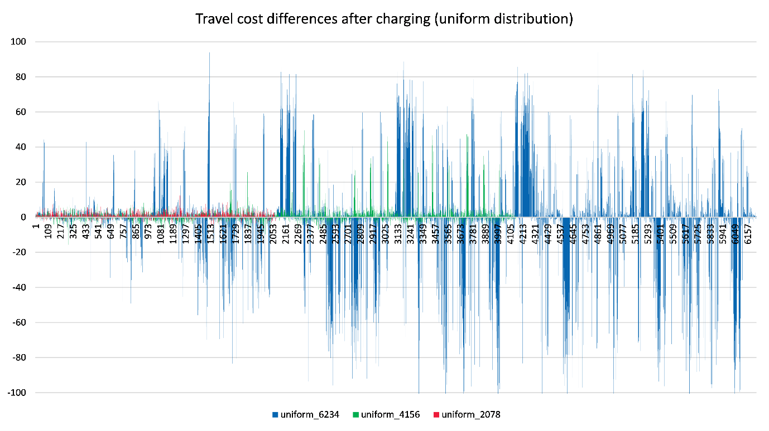

Figure1.Travel cost difference after charging (uniform distribution)

Table 1 indicates different levels of travel cost difference after the charging strategy.

Table 1. Levels of travel cost difference

|  |  |  |  |
| --- | --- | --- | --- |
| **Index** | **uniform_2078** | **uniform_4156** | **uniform_6234** |
| **0-1** | 27.24% | 19.18% | 11.13% |
| **1-10** | 46.15% | 37.99% | 26.20% |
| **10--50** | 0.10% | 3.10% | 11.15% |
| **50-100** | 0.00% | 0.00% | 5.66% |
| **100-150** | 0.00% | 0.00% | 0.00% |
| **150-200** | 0.00% | 0.00% | 0.00% |
| **Sum** | 73.48% | 60.27% | 54.14% |

Table 1. Percentage of travel cost differences

